KPI’S

TOTAL SALE:
SELECT sum (sales) AS Total_sales FROM logistics;

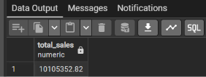

TOTAL ORDERS BY REGION:
SELECT Region, COUNT (Order_ID) as Total_order from logistics
GROUP BY Region
ORDER BY Total_order desc;

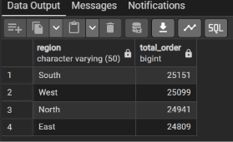

TOTAL ORDERS:
SELECT COUNT (order_id) as Total_order from logistics;

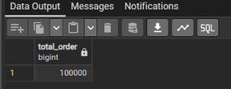

TOTAL SHIPPING COST:
SELECT SUM (shipping_cost) as total_shipping_cost from logistics;

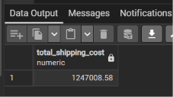

TOTAL SALE BY REGION:
SELECT Region, SUM (sales) as Total_Sales from logistics
GROUP BY Region
ORDER BY Total_sales asc;

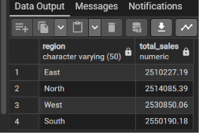

AVERAGE DELIVERY TIME IN DAYS:
SELECT ROUND (AVG (Delivery_Date - Order_Date), 2) as Average_delivery_time_in_days from logistics;

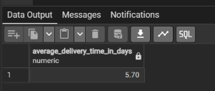

(OTD) ON-TIME DELIVERY :
SELECT COUNT (Order_ID) as Total_orders,
ROUND (COUNT (*) FILTER (WHERE Actual_Delivery_Days <=7) *100.0 / COUNT (*), 2) as on_time_orders FROM logistics;

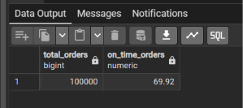

(Note:- Instead of using a WHEN statement inside a SUM. In PostgreSQL we can directly use the filter functions which filter our query or data as above. )

- What I Learned From This Data
- The East and North regions have the worst delays. Even though they make good sales, their shipping times are dragging down our brand reputation.
- Our shipping modes need better management. Customers are paying for faster delivery, but a huge portion of orders are still arriving late.

